Conference Seating Options
Theatre Style

Cabaret Style

Classroom
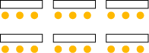

.
Boardroom Style
